BIO-MATHEMATICS

ASSIGNMENT



MUHAMMAD SAMSUDDIN

NOAKHALI SCIENCE AND TECHNOLOGY UNIVERSITY

**2020**

Biomathematics (also known as mathematical biology and by some of it subfields including computational biology or systems biology) is an interdisciplinary field that uses mathematical techniques and tools to model natural and biological processes.

BIO-MATHEMATICS

BIO-MATHEMATICS

ASSIGNMENT

NOAKHALI SCIENCE AND TECHNOLOGY UNIVERSITY



**Applied Mathematics**

**Dr. Md. Hanif Murad**

**Professor,**

**Chairman,**

**Department of**

**Submitted to……….**

**Submitted by…………**

**31-JULY-2020**

**Muhammad Samsuddin**

**ASH-1606070M**

**Y-04 T-01**

**2016-17**

**Applied Mathematics**

**Question 1.** **Describe the simple SIR epidemic model. Find the condition on which the infection (disease) will ultimately die out or spread throughout the population.**

**Answer:**

Most epidemic models are based on dividing the host population ) into a small number of compartments, each individuals that are identical in terms of their status with respect to the disease in question. In the SIR model, there are three compartments:

• Susceptible s(t) : individuals who have no immunity to the infectious agent, so might become infected if exposed

• Infectious I(t) : individuals who are currently infected and can transmit the infection to susceptible individuals who they contact

• Removed R(t) : individuals who are immune to the infection, and consequently do not affect the transmission dynamics in any way when they contact other individuals.

This is schematically represented by

Such models are called SIR models.

Due to infection the number of susceptible decreases and the number of infected persons increase. Thus, for preparing mathematical model the following assumption are to be considered.

1. The gain in the infectective class is at a rate proportional tp the number of infective and susceptible .that is , rSI, where r < 0 is constant parameter.
2. The rate of removal of infectives to the removed class is proportional to the number of infectives , that is , aI here a . 0 is a constant.
3. The incubation period is short enough to be negligible .thus, the model based on the above assumption.

Where r > 0 is the infection rate and a > 0 the removal rate of infectives. This model is the classic **kermack-mckendrick** model.

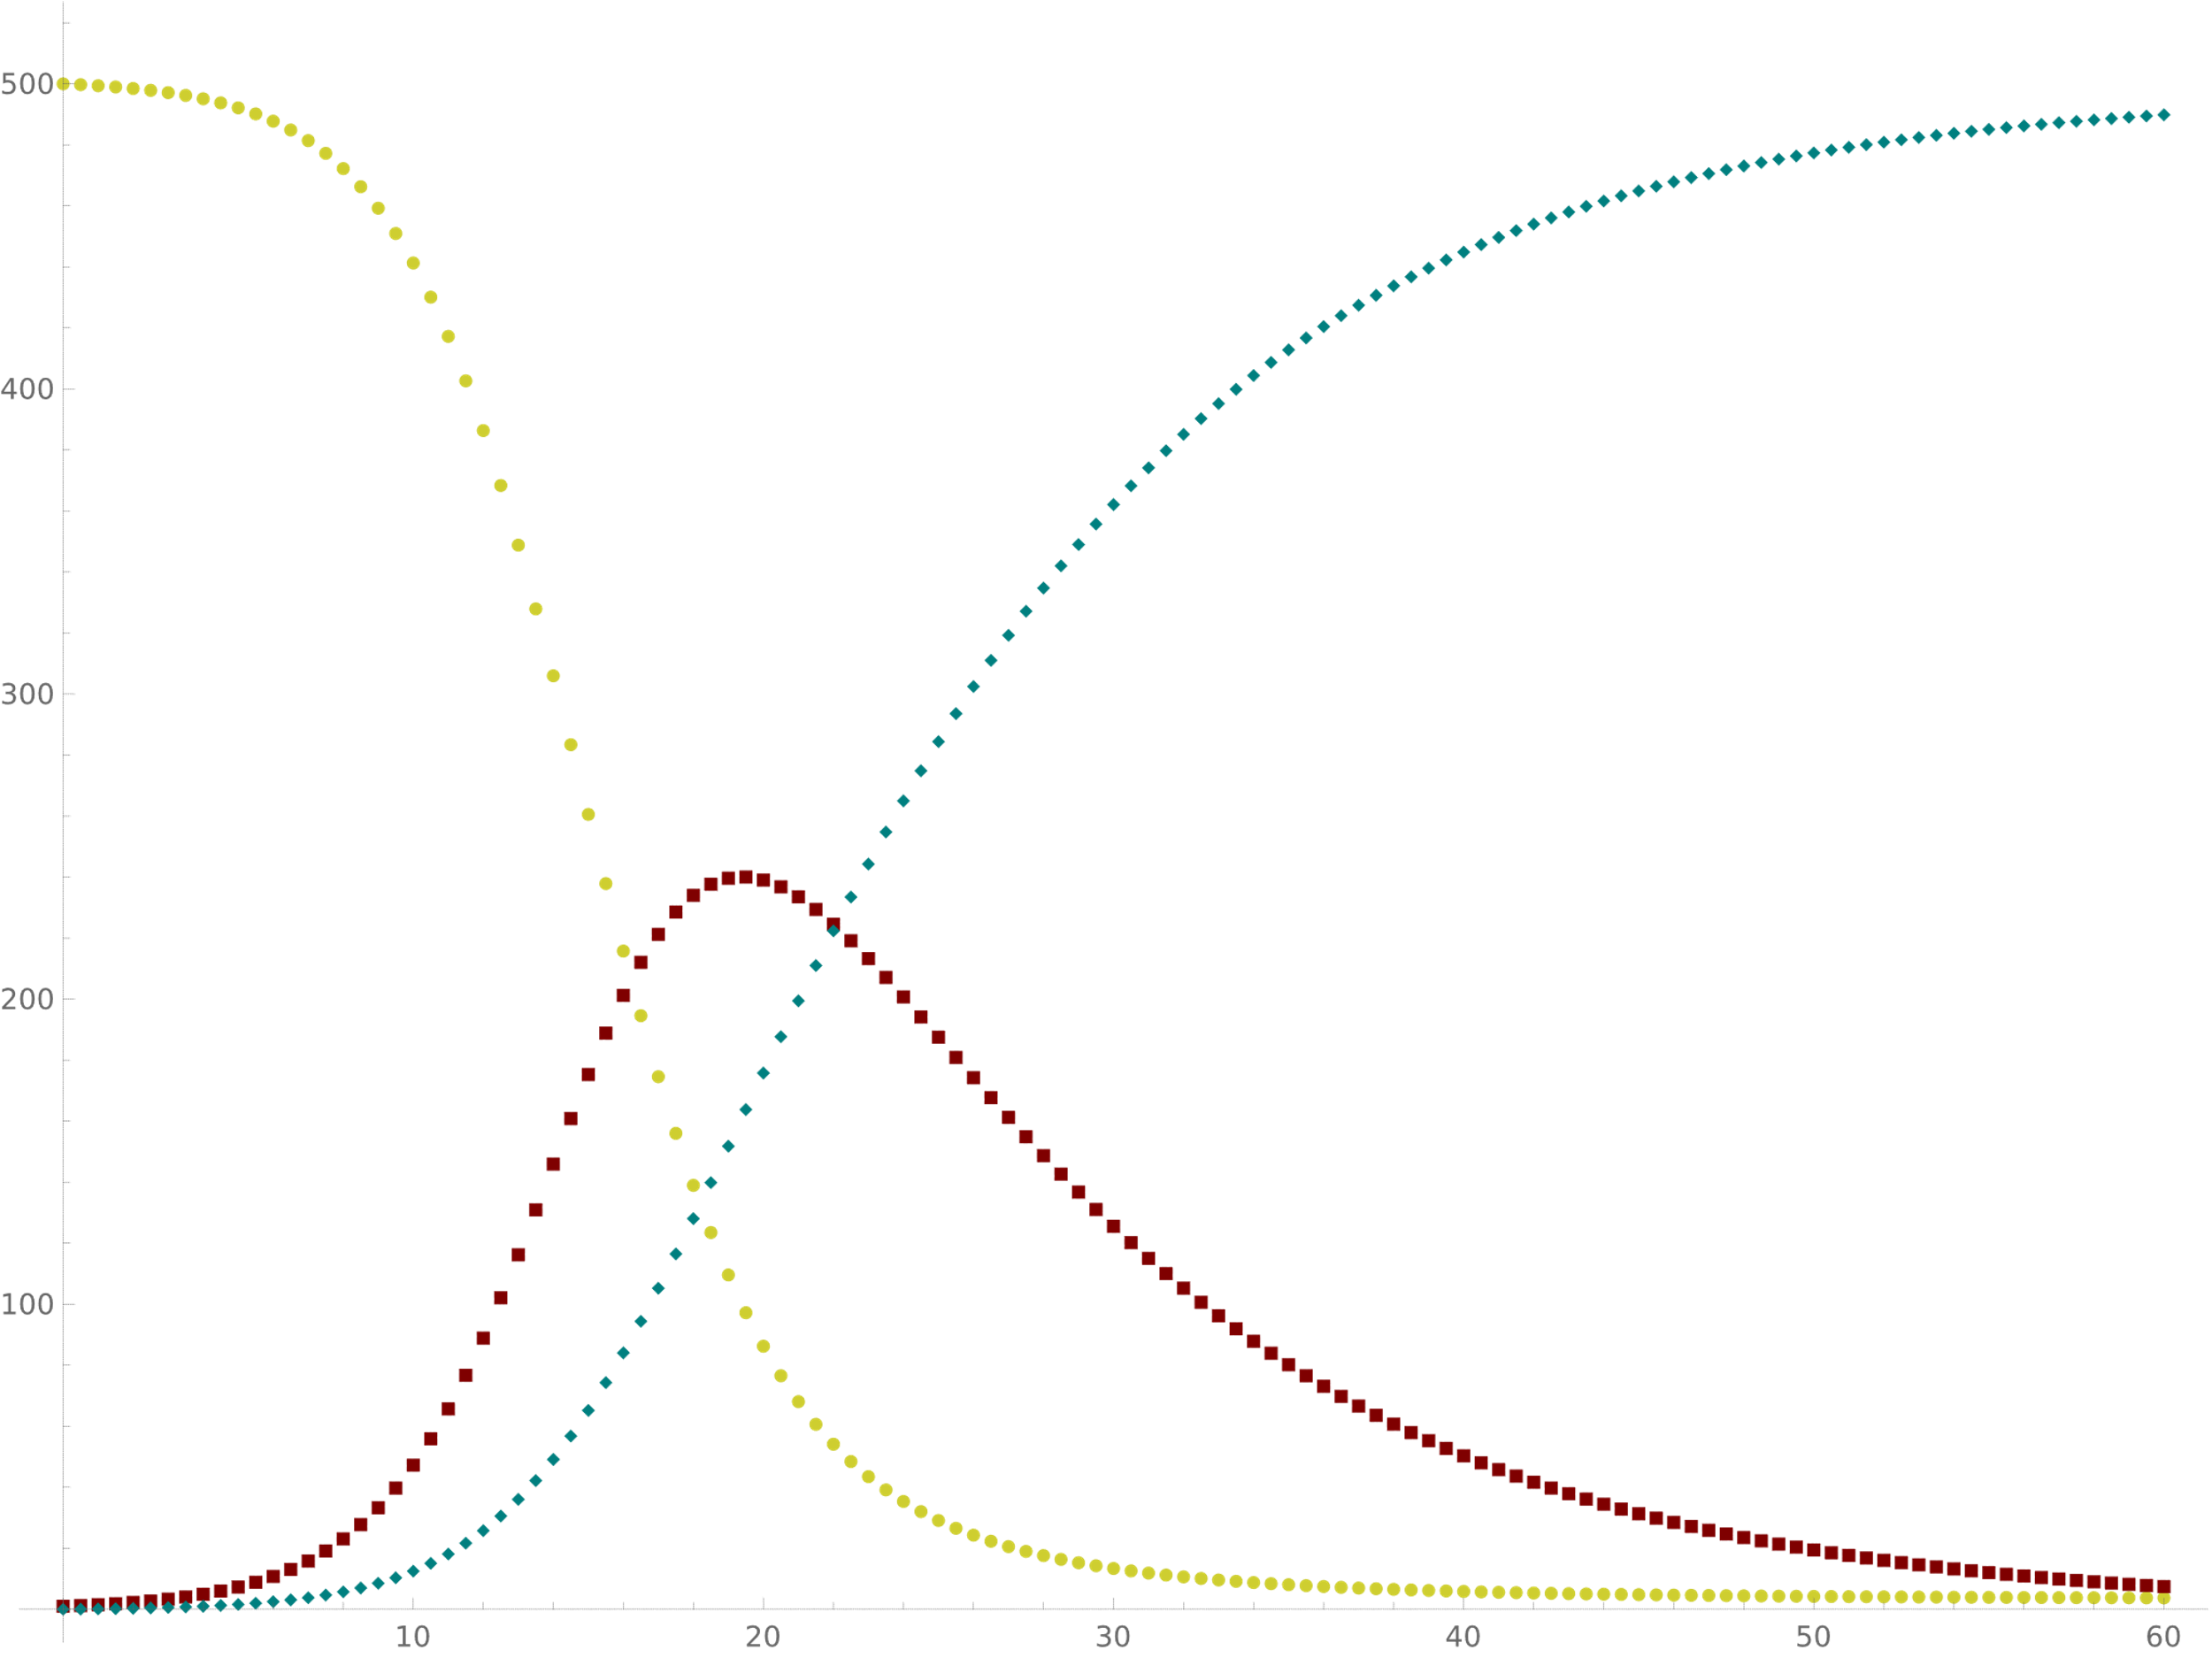

Susceptible

Recovered

Infectious

If N(t) be the total population size. Then by adding (1),(2) and (3) we get

Thus S,I and R are all bounded above by N. the initial condition of the above model

The purpose of study of the model is given r,a, whether the infection will be spred or not, and if it does how it develops with time and crucially when it will start to decline.

From (2) we have ,

${\left[\frac{dI}{dt}\right]}_{t=0}=I_{0}\left(rS_{0}-a\right)\left\{\begin{aligned}>0 if S_{0}>ρ=\frac{a}{r} \\ <if S_{0}<ρ=\frac{a}{r} \end{aligned}…….\left(6\right)\right.$

Since from (1) we have ,

$\frac{dS}{dt}≤0,S≤S_{0}$

If $S_{0}<\frac{a}{r} then\frac{dI}{dt}=I\left(rS-a\right)≤0…….\left(7\right)$

For all $t≥0$ in which case $I_{0}→0 as t→∞. so the infection dies out and no epidemic can$

Occur .if $S_{0}>\frac{a}{r} then I(t)$ initially increase and so spread throughout the population.

**Question-(2): Interpret the epidemic model:**

$\frac{ds}{dt}=-rSI$

$\frac{ds}{dt}= rSI-aI$

$\frac{ds}{dt}= aI$

Answer:

Most epidemic models are based on dividing the host population ) into a small number of compartments, each individuals that are identical in terms of their status with respect to the disease in question. In the SIR model, there are three compartments:

• Susceptible s(t) : individuals who have no immunity to the infectious agent, so might become infected if exposed

• Infectious I(t) : individuals who are currently infected and can transmit the infection to susceptible individuals who they contact

• Removed R(t) : individuals who are immune to the infection, and consequently do not affect the transmission dynamics in any way when they contact other individuals.

This is schematically represented by

Such models are called SIR models.

Due to infection the number of susceptible decreases and the number of infected persons increase. Thus, for preparing mathematical model the following assumption are to be considered.

1. The gain in the infectective class is at a rate proportional tp the number of infective and susceptible .that is , rSI, where r < 0 is constant parameter.
2. The rate of removal of infectives to the removed class is proportional to the number of infectives , that is , aI here a . 0 is a constant.
3. The incubation period is short enough to be negligible .thus, the model based on the above assumption.

Where r > 0 is the infection rate and a > 0 the removal rate of infectives. This model is the classic **kermack-mckendrick** model.

Susceptible

Recovered

Infectious

If N(t) be the total population size. Then by adding (1),(2) and (3) we get

Thus S,I and R are all bounded above by N. the initial condition of the above model

The purpose of study of the model is given r,a, whether the infection will be spred or not, and if it does how it develops with time and crucially when it will start to decline.

From (2) we have ,

${\left[\frac{dI}{dt}\right]}_{t=0}=I_{0}\left(rS_{0}-a\right)\left\{\begin{aligned}>0 if S_{0}>ρ=\frac{a}{r} \\ <if S_{0}<ρ=\frac{a}{r} \end{aligned}…….\left(6\right)\right.$

Since from (1) we have ,

$\frac{dS}{dt}≤0,S≤S_{0}$

If $S_{0}<\frac{a}{r} then\frac{dI}{dt}=I\left(rS-a\right)≤0…….\left(7\right)$

For all $t≥0$ in which case $I_{0}→0 as t→∞. so the infection dies out and no epidemic can$

Occur .if $S_{0}>\frac{a}{r} then I(t)$ initially increase and so spread throughout the population . in this case we have an epidemic . so $S_{0}>\frac{a}{r}$ then there is ab epidemic but if $S_{0}<\frac{a}{r}$ then there is not. Sometimes the parameter $ρ=\frac{a}{r}$ is called the relative removal rate and irs reciprocal $σ(=\frac{a}{r}$) the infections contract rate . we write $R_{o}=\frac{rS_{0}}{a},$ where $R_{0} is the basic reproduction rate of rhe infection$

And $\frac{1}{a}$ is the avarage infection period.

From (1) and (2) we have,

$$\frac{dI}{dS}=\frac{rSI-aI }{-rSI}=-1+\frac{ρ}{S}, where ρ=\frac{a}{r}$$

$$⇒∫dI= -∫dS+ρ\int{\frac{1}{S}} dS$$

$$⇒I= -S+ρ InS+constant$$

$$⇒I+S-ρ In s=constant=I_{0}+S_{0}-ρ In S_{0}….\left(8\right)$$

From (7) we have I will be maximum if

$$\frac{dI}{dt}=0$$

$$⇒I\left(rS-a\right)=0$$

$$⇒rS-a=0,$$

$$⇒S=\frac{a}{r}=ρ$$

Putting $S=ρ in \left(8\right)we get$

$$I_{max}+ρ-ρ In ρ=I_{0}+S_{0}-ρ In S_{0}$$

$$⇒I_{max}=-ρ+ρ In ρ+I_{0}+S_{0}-ρ In S_{0}$$

$$=I_{0}+\left(S_{0}-ρ\right)+ρ In\left(\frac{ρ}{S_{0}}\right)…..\left(9\right)$$

$$=N-ρ+ρ In \left(\frac{ρ}{S_{0}}\right), I_{0}+S_{0}=N$$

If $I_{0}>0 and S_{0}>ρ, the the phase trajectory start with S>ρ$

Also in this case I increase from $I_{0}$ and hence an epidemic occoures .

From (1), $\frac{dS}{dt}<0 for S ≠0, I≠0.$

$$⇒S decrease$$

From (1) and (3) we have

$$\frac{dS}{dt}=\frac{-rSI}{aI}=-\frac{S}{ρ}$$

$$⇒∫\frac{1}{S}dS= -\frac{1}{ρ}∫dR$$

$$⇒In S= -\frac{R}{ρ}+A…..\left(10\right)$$

Where A is a integrating constant

Initially ,

$$S=S_{0} and R=R\left(0\right)=R_{0}=0$$

$$∴In S_{0}=0+A⇒A=In S_{0}$$

Putting this value in (10) we get

$$In S=-\frac{R}{ρ}+InS_{0}$$

$$⇒In \left(\frac{S}{S_{0}}\right)= -\frac{R}{ρ}$$

$$⇒\frac{S}{S_{0}}=e^{-\frac{R}{ρ}}$$

$$⇒S=S_{0} e^{-\frac{R}{ρ}}$$

$$⇒S=S_{0}e^{-\frac{R}{ρ}}≥S_{0}e^{-\frac{N}{ρ}}>0….\left(11\right)$$

$$⇒0<S\left(∞\right)≤N$$

Since $I\left(∞\right)=0 , \left(4\right)imlies$

$$R\left(∞\right)=N-S\left(∞\right).$$

Thus from (11) we get ,

$$S\left(∞\right)=S_{0}\exp\left[-\frac{R\left(∞\right)}{ρ}\right]=S_{0}\exp\left[-\frac{N-s\left(∞\right)}{ρ}\right]$$

Which shows that $S(∞)$ is the positive root $0<z<ρ$ of the transcedental equation

$S_{0}\exp\left[-\frac{N-z}{ρ}\right]=z………\left(12\right)$

Thus , we get the total of susceptible who catch the disease in the course of the epidemic as

$$I_{total}=I_{0}+S_{0}-S\left(∞\right)………….\left(13\right)$$

From this analysis , namely $I\left(t\right)→0 and S\left(t\right)→\left(∞\right)>0$ we have , the disease dies out from a lack of susceptibles.Epidemic ensures when $S_{0}>ρ$ but not when $S_{0}<ρ.$ this shows that $S_{0}$ plays major role. If the density of susceptibles is high and the removal rate ,a , of infectives is low then an epidemic is likely to occur

From (11),(4) and (3) we have

$$\frac{dS}{dt}=aI=a\left(N-R-S\right)$$

$$⇒\frac{dR}{dt}=a\left(N-R-S_{0}e^{-\frac{R}{ρ}}\right), R\left(0\right)=0…….\left(14\right)$$

This can be solved analytically. Also. if we know a,r,S0 and N then (14) can be solved numerically.

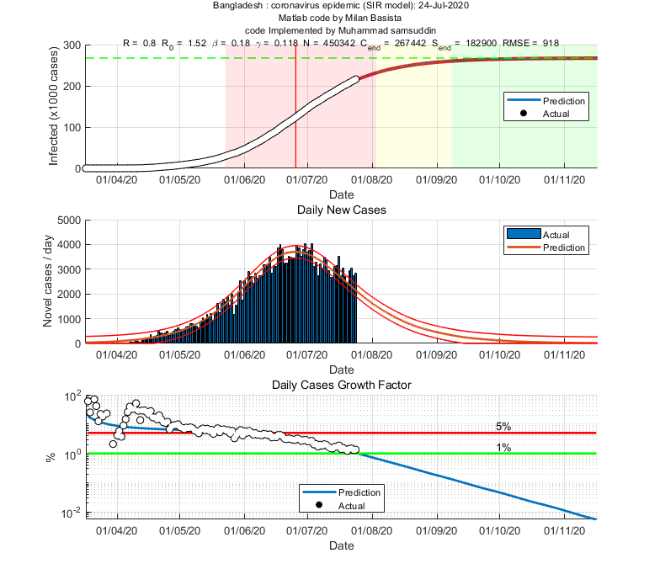Example: the SIR epidemic model of COVID-19 for Bangladesh